MORWELL GOLF CLUB INC.
CHICKEN RUN Date: 10th March 2022
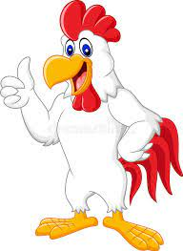

Winners Club Registered Golfers Non-Club Registered Golfers

Men’s Front Nine: R. Leeworthy 30 C/B Dion Tanti 33

Men’s Back Nine: Bill Simpson 29 Tim Johnson 36

Ladies Either Nine: Glenda Clark 45 (1 ball)

NTP: 8th Men Ben Swanson Ladies

NTP: 11th Men Ben Kamphuis Ladies

DTL: Men’s Club Golfers:
B. Rigby 30, P. Coad 32, L. White 32, R Lang 32, T. Piper 33, Dale Aust 33, G. Barnes 33, J. Backman 33, J. Langstaff 33 C/B

DTL: Non-Club Golfers:
H. Cook 35, M. Cardillo 35, P. Hehir 38

Raffle: 1 Ian Charles ($20.00) 2 Peter Barnett ($10.00)
3 Rosalie ($10.00) 4 Nicole Knowles (S10.00)
5 Eric Harrison ($10.00) 6 Jenny Grimshaw ($10.00)

Starters: 90 Men: 89 Ladies 1

