MORWELL GOLF CLUB INC.
CHICKEN RUN Date: 10th March 2022
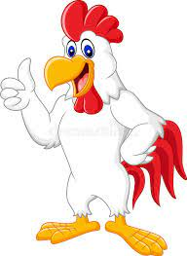

Winners Club Registered Golfers Non-Club Registered Golfers

Men’s Front Nine: Willie 29 Brett Treadwell 32

Men’s Back Nine: Dale Burridge 32 A. Distefano 34

Ladies Either Nine: Nicole Knowles (1 ball)

NTP: 8th Men Stan Baker Ladies

NTP: 11th Men J Rigdon Ladies

DTL: Men’s Club Golfers:
Tony Carolan 31, G. Thorburn 31, R. Cooen 32, J. Kuhne 32, J. Langstaff 33, B. Rigby 33, B. Hennessy 33, R. Leeworthy 33.

DTL: Non-Club Golfers:
M. Reynolds 36, M Treadwell 36, D. Symons 37, P. Williams 37

Raffle: 1 Dimy K. ($10.00) 2 Rod King ($10.00)
3 Peter Barnett ($10.00) 4 Simon Stephens (S10.00)
5 Ben Swanson ($10.00) 6 Jenny Grimshaw ($10.00)

Starters: 78 Men: 76 Ladies 2

